GV60 design that speaks luxurious EV - Design review
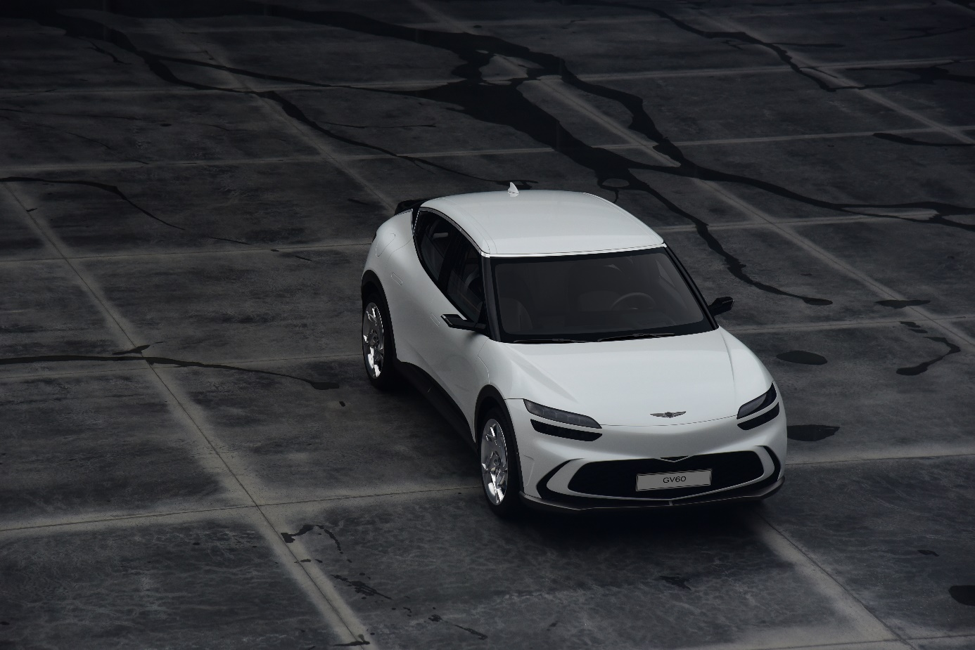
Tomorrow’s drivers are expecting more from their vehicles, with EVs at the forefront of a bold new era in mobility. With the introduction of the GV60, Genesis is redefining the experience of luxury electric vehicles, combining youthful athleticism with sustainable technology to create a new path for drivers who are focused on a better future.

But the GV60 does much more than bring luxury driving to an EV - offering style, power, and sustainability all in one place. With design details, the GV60 creates unbounded mobility experiences that are tailored to our modern lifestyles.

From interactive driving features to exterior details that transcend boundaries, here are some design highlights from the GV60.

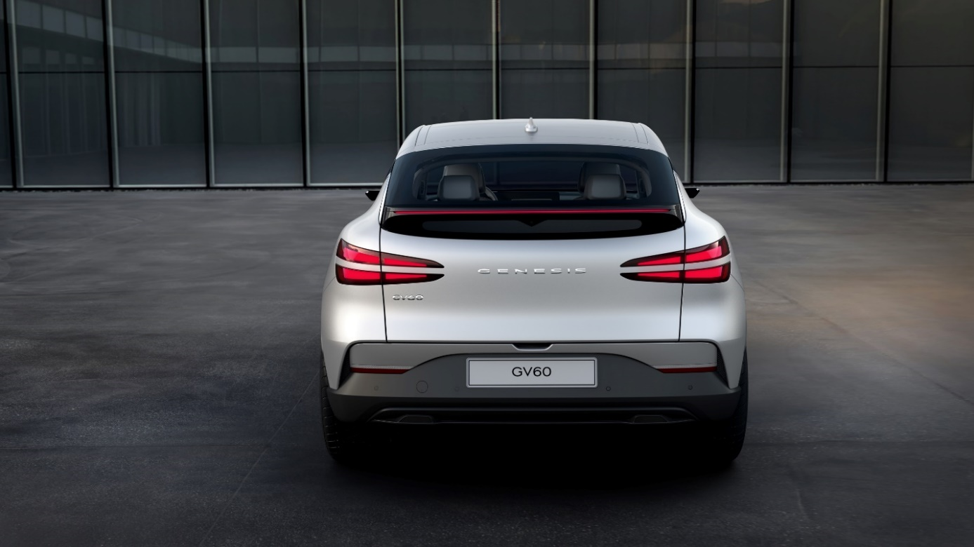



Quad Lamps
The Quad Lamps resulting in the distinctive Two Lines graphic down to side is one of the most unique design signatures of Genesis. The GV60 reinterprets and enhances this signature into a sporty, dynamic double wedge that emphasizes the GV60 as the most athletic Genesis ever. When you see the fast moving Two Lines signature on the road passing by in silence, it can only be a GV60. The Two Lines are us.

Side profile
The GV60’s body surfacing is seamless and minimal without undercuts or character lines. Yet the muscular volumes bulging beneath the surface pushing out the wide stance characterize power and presence like never before. Silent yet powerful, the GV60’s subdued inner confidence breaks from the loud performance aesthetics of the past.


The GV60’s side profile is completely unique with an EV specific typology. The sleek coupe silhouette ending with the unmistakable rear spoiler and the long wheelbase with short overhangs creates a unique performance aesthetic that dares to be audaciously different and unexpected. This is the new shape of performance.


Chrome line DLO
The distinctive, non-conformist DLO chrome trim of the new GV60 wraps around the windscreen and flows towards the rear spoiler supporting the floating roof and connecting it with the C pillar through the "Volt DLO". This characterful and unique DLO chrome trim emphasizes the GV60 as the most athletic, youthful character in the range, and is another gesture signaling that there are no rules or boundaries written in the EV era.

Crystal sphere
The Crystal Sphere is the highlight of the GV60’s interactive features. First and foremost, the Crystal Sphere is a safety feature that clearly indicates whether the vehicle is turned on or not. This is important for a vehicle as silent as an EV where the only indication of driving state are small onscreen icons. When charging, the Crystal Sphere does not rotate to driving mode. A kind reminder of the current status of the GV60.

At Genesis we speak about emotional functionality. We created beauty where beauty didn’t exist in the beautiful Crystal Sphere with its laser engraving and user configurable mood lighting. Safety and function wrapped up in emotional beauty. This is our obsession to the very last detail.

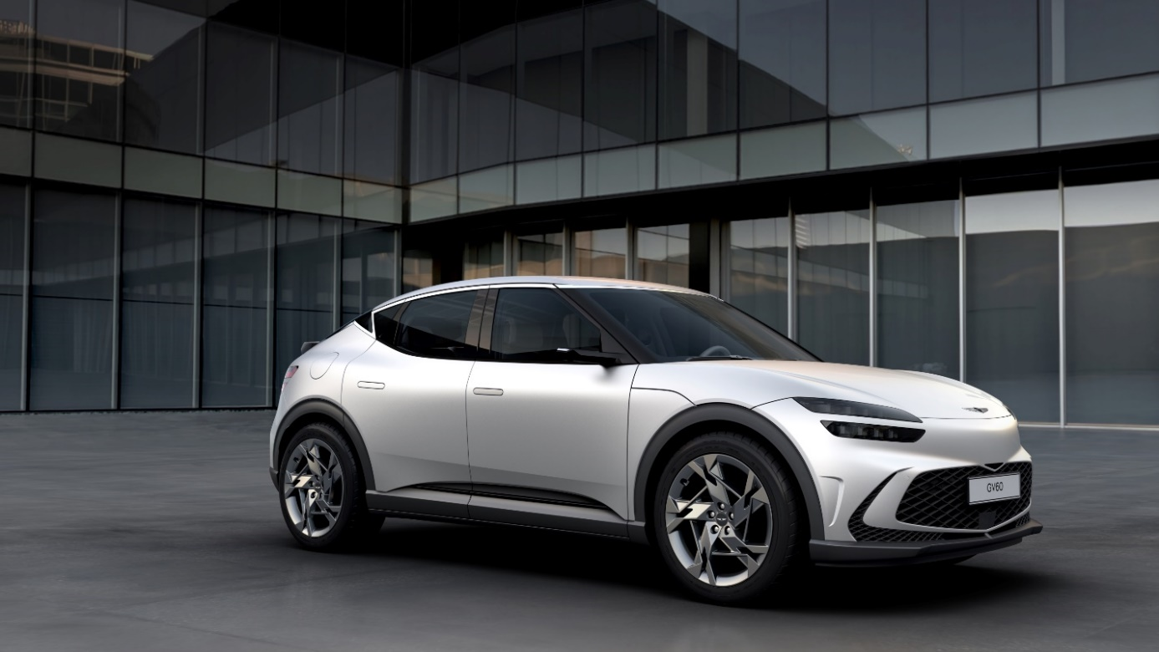
Bold design characteristics meet intelligent driving in Genesis GV60, marking the start of a new era in luxury electrification. For the drivers of tomorrow who expect sustainable solutions and won’t be held back by barriers to design or performance, the GV60 is taking them forward into the new era of mobility, with improved design at the forefront.

# # #

