GENESIS EARNS IIHS TOP SAFETY PICK+ DESIGNATION ACROSS ENTIRE LINEUP FOR FOURTH CONSECUTIVE YEAR

- Genesis models provide the latest technologies for customers with safety as their top priority

FOUNTAIN VALLEY, Calif., Feb. 24, 2022 – Today, the Insurance Institute for Highway Safety (IIHS) announced that all 2022 model year Genesis models have been designated as TOP SAFETY PICK+ (TSP+) for 2022 (for G70 built after June 2021). This marks the fourth year in a row that the entire Genesis lineup of eligible vehicles has earned top honors.
“At Genesis, safety is our top priority and the customer is at the center of every decision we make,” said Claudia Marquez, chief operating officer of Genesis Motor North America. “Safety is emphasized in the design and engineering of our award-winning vehicles.”
All Genesis models are equipped with a comprehensive suite of state-of-the-art driver assistance and safety technologies including Forward Collision Avoidance-Assist with Pedestrian Detection, Lane Keep Assist, Blind-Spot Collision Warning and more. Each vehicle in the Genesis line-up offers sure-footed handling thanks to the rigid chassis construction that ensures firm stability even under the most challenging driving conditions.
“Genesis vehicles offer exceptional safety performance, and we are pleased that our high standard for safety has been recognized by IIHS across our entire lineup,” said Brian Latouf, chief safety officer of Genesis Motor North America. “With their innovative active crash avoidance technologies and advanced crashworthiness features, we are pleased that our vehicles continue to perform well in the IIHS tests.”
Genesis vehicles are equipped with the latest in safety and driver assistance technologies, including:
- 8 or more standard airbags, including some of the only front center airbags on the market in all models introduced from 2021, further protecting front cabin occupants in the event of a collision
- Forward Collision Avoidance-Assist, mitigating the risks of collisions with vehicles, pedestrians, and cyclists in certain conditions
- Blind-Spot Collision Avoidance Assist, helping reduce the chance of potential impact with a vehicle in the blindspot
- An innovative platform – with strong focus on safety – including passenger compartment protection and reinforcement areas using advanced high strength steel for rigidity and safety.

Safety reminder – Please buckle-up!
Seat belts save lives every day. Always wear seat belts and use appropriate restraints for all child passengers.

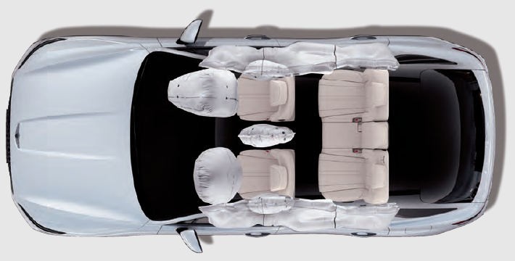

-30-

Genesis Motor North America

At Genesis, we put the customer at the core of everything we do. Genesis is a global automotive brand that delivers the highest standards of safety, performance, design, and innovation. Genesis offers a range of models including the G70 sport sedan, G80 executive sedan, the flagship G90 sedan, and the GV70 and GV80 sport utility vehicles.

Please visit our media site for the latest news at www.genesisnewsusa.com (United States) and www.genesisnews.ca (Canada).

For more information, interviews, and images, please contact:
Jarred Pellat
Manager, Public Relations
Genesis Motor North America
Mobile: 949-683-0637
Email: jpellat@gma.com

